Invitation to Tender

James Ford – s4908388

eSolutions

Jurassic Adventure

Jurassic Adventure



Contents

Table of Figures: 2

Section 1 – Product Specification and Features: 3

Overview 3

1.1 – Key Features: 4

1.2 – Additional Features: 7

1. 3 – Engage Target Audience: 8

Section 2 – Product Development Plan: 9

2.1 – Resources Needed: 9

2.2 – Product Development Plan: 10

2.2.1 – Project Structure: 10

2.2.2 – Tasks and Sub-Task Definition: 10

2.2.3 – Task Duration & Resource Allocation: 10

2.2.4 – Building the Project Schedule: 11

2.2.5 – Setting Milestones: 12

2.2.6 – Global Project Parameters within MS Project 2016: 12

2.2.7 – Gantt Chart Appearance: 12

Section 3 – Financial & Commercial Data: 13

3.1 – Estimated Costs: 13

3.1.1 – Total Cost: 13

3.1.2 – Staffing Cost: 14

3.1.4 – Specific Resources & Equipment: 16

3.1.5 – Project Management Cost: 16

3.1.6 – Contingency Costs: 17

3.1.7 – Profit Margin: 17

3.2 – Payment Plan: 17

3.3 – Copyright & Intellectual Property Rights: 18

3.4 – Support & Updates: 18

Appendix: 19

Work Breakdown Structure: 19

References: 22

Figures: 22

Freelancers: 23

Websites: 23

# Table of Figures:

Figure 1 - Overview 3

Figure 2 - Basic Level Concept 4

Figure 3 - Triceratops, Tyrannosaurus Rex & Pterodactyl 5

Figure 4 - Activity Example 6

Figure 5 - Leader Board 7

Figure 6 - Achievements 7

Figure 7 - Activity Sheets 8

Figure 8 - Kids Testing 8

Figure 9 - Internal Staff 9

Figure 10 - Top Level Themes 10

Figure 11 - Task Breakdown 10

Figure 12 - Manual Scheduling 11

Figure 13 - Recurring Tasks 11

Figure 14 - Project Calendar 12

Figure 15 - 3D Model Milestones 12

Figure 16 - Gantt Chart Appearance 12

Figure 17 - Graph of Expenditure 13

Figure 18 - Cost Summary 13

Figure 19 - Staff Salary 14

Figure 20 - Freelancer Cost 14

Figure 21 - Infrastructure Overhead Costs 15

Figure 22 - Money Super Market Quote (PL) 15

Figure 23 - 2020 Total Overhead Costs 15

Figure 24 - Specific Costs 16

Figure 25 - Portable Hard Drive 16

Figure 26 - Hotel Prices 16

# Section 1 – Product Specification and Features:

## Overview

eSolutions is an app development company based in the Bournemouth/Poole conurbation, it was founded in 2014 by two graduates with computing & games development backgrounds. We specialize in creating educational learning apps and have dabbled with bespoke software for schools and colleges. With increased interest and flare when it comes to the Natural History & wildlife genres.

The application will be developed and tested for android marshmallow originally then it will be updated to work with all higher versions of androids, after this it will be ported to IOS 12 and higher, once the phone ports are completed the application will be modified to have more resolution and format options so that it can work correctly on tablet devices. The project will be produced in the Unity Engine, Unity has a large number of options built into it that help with the creation of applications, these can include the option to export the current file as Android or IOS files and being able to specifically pick which versions of each, hassle-free. The application will be orientated landscape, this makes the most sense for a side-scroller game. this orientation is also best for videos & 3D model viewing. The menu buttons are large to make precise clicks easy on smaller devices, they will scale with the resolution. The whole application is touch screen and it will handle swipe gestures in some places. Mostly in puzzles or in the dinosaur list screen.

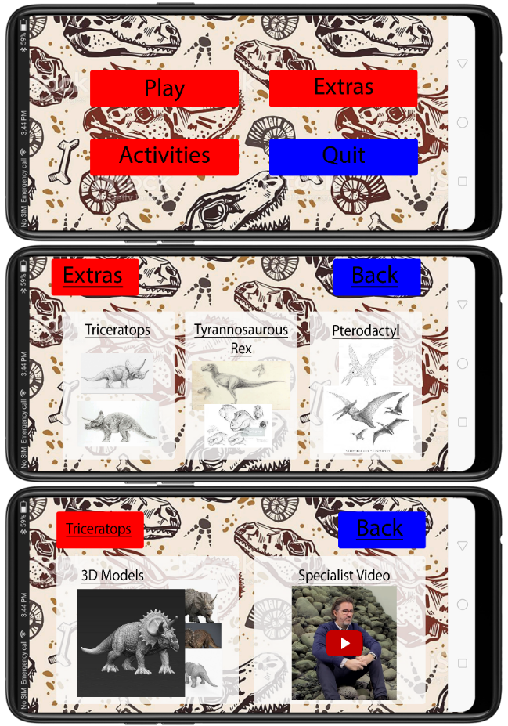

Figure 1 - Overview

1). The home page of the app will be simplistic & clear, with an obvious dinosaur theme.

2). The play button leads to the game, activities loads a screen with a large list of viewable, downloadable & printable activity sheets.

3). Extras will load a page similar to this that will allow you to select the dinosaur you wish to view more information about.

4). I Decided to have the dinosaur selection page segregated so that if you museum wanted to hire us again to add more dinosaurs to the game then the UI would already be capable of it.

5). When you select one of the dinosaurs it will lead you to another segregated page that allows you to see all of the 3D models & concept art. It also holds the specialist video to be viewed whenever.

6). This is also separated so that we can come back later and add more to the app easily.

## 1.1 – Key Features:

Interactive Historical Landscape:

The landscape will be different for the three different levels that will be implemented in the game, they will all be closely linked to the specific dinosaur that needs to be caught in that level. The map will have a ton of interactive objects scattered throughout it, this will help make each level feel substantially bigger than they will be. The player will have to complete puzzles, quizzes and jumping puzzles to unlock new activity’s to ultimately lay a trap for the specific dinosaur and capture it.

There will be signposts throughout the levels that will have facts and answers for the quizzes that will be throughout the game. The three landscapes will have big differences from one-another even though two of them (Triceratops & Tyrannosaurus Rex) are from the Cretaceous Period, these two will instead be based around herbivores & carnivores respectively. The third level will be based around teaching people the key difference between the Cretaceous period and the Jurassic period.

The landscape will be built in the Unity Engine, it will have a number of assets that comprise it, most of which will be made using Photoshop. Any 3D models that will be added will be made using 3DS Maya and textured using Substance Painter. All of the information will be gathered from the museum, either from members of staff at the museum or from gathering information from a number of exhibits, this information will be used for the signposts and quizzes. The voiceovers will be recorded when we hire the video & audio recording hardware, these will be for the signposts.

I’m going to have the lead developer working on this, he is also going to be joined by the junior developer 1 so they can handle the media elements that will be intractable. The art is going to be covered by the 2D/3D artist. I think the interactive Landscape could take up to about 2 months, this is to make sure that we can get a large amount of detail and assets in the landscapes to make sure they feel full and vibrant.

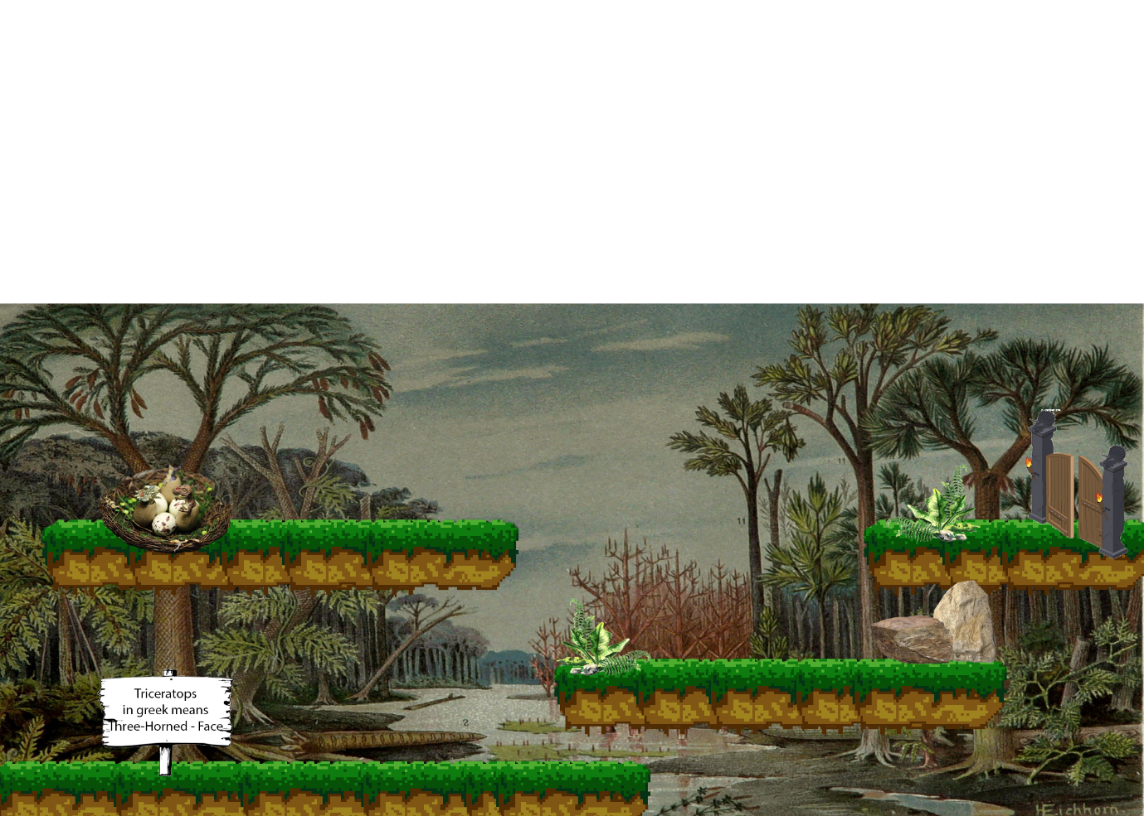

Figure 2 - Basic Level Concept

3D models:

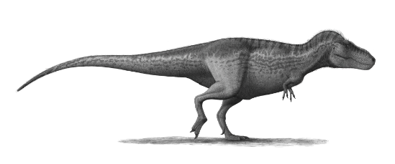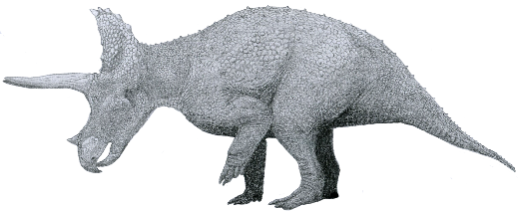

Figure 3 - Triceratops, Tyrannosaurus Rex & Pterodactyl

The three 3D models will be used throughout the levels that they pertain to, you will start each level with a pre-rendered cut-scene of the specific dinosaur eating/idling they then notice you and run away. From this point on they will be at various stages of the level, up until you trap them where they will have individual capture animations. The models will be to their relative sizes to give a sense of scale to the scene. Once the specific dinosaur has been re-captured then that particular 3D model and animation set will be unlocked on the main app screen.

The high poly versions of the models will be made in ZBrush, these models will be used for the textures of the low poly & for the education video. Then we would make the low poly version in 3Ds Maya, it would also be animated in Maya. Substance painter will be used to bake the textures from the high poly onto the low poly.

The models will be made by the 3D artist and modeller, they will get occasional help from the 2D/3D artist on some of the more basic tasks, and if a model needs to be hurried along then I will have to plan for a contingency of hiring any freelance help that may be needed. To get such a large amount of detail in the videos, the models will have to be made at a super high poly count, this can take up to 4-5 months of time with a single 3D modeller working on it.

Educational Videos:

These videos will be part of the level end cut-scene, once you have captured the specific dinosaur then the video pertaining to it will play and give the player a greater detail about the dinosaur and allow the museum to show off some of the installations & animations, they have for it. These videos will then be unlocked on the main app screen to be played again at the user’s pleasure.

The videos will be outsourced to a professional Videography Company, we may need to use some of the exhibits of the museum in the videos for size/scale context and to show off some of the dinosaur’s key features, some exhibits may be used for the background of the videos as well. Aside from this, the Videography Company should have the recording & editing software at their disposal. The animations of the 3D models will be provided to the Videography Company so that they can implement them into the videos as well.

Most of this will be handled by the freelance Videography Company, the Managing Director will work with the company to make sure the product is as requested. The videos are estimated to take about a week to film and 8-10 hours to edit for each, this estimation can be found at (Reddit.com, 2019).

Learning Activities:

There will be a large number of learning activities that are available from the app menu, these won’t be locked at any point and can be accessed as soon as you download the app. These will include a decently large amount of crosswords, Colouring sheets, word-searches, and printable fact-sheets. Some of these will appear throughout the game as some of the puzzles. All of the activities can be downloaded and used freely, you will also be able to print any of the activities for a classroom like environment.

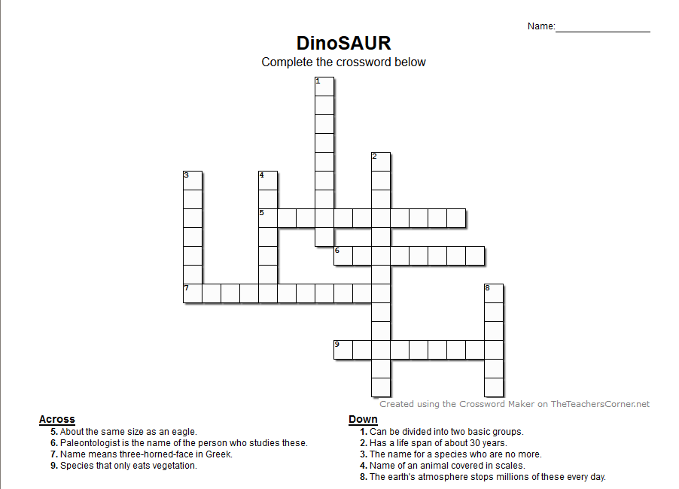

Figure 4 - Activity Example

There are a number of websites that allow you to make & design a huge amount of learning activities, these include (Worksheets, 2019) and (Puzzlemaker, 2019). As for the colour sheets, the 2D artist can make a number of dinosaur pictures to colour in. the fact sheets will be made in Microsoft Word, the facts will be collected from the museum.

The Junior Developer 1 will spend some time making a huge amount of resources for the offline activities, whilst the 2D/3D artist makes some colouring sheets. Completing a huge amount of learning activities shouldn’t take long at all, its estimated to take about two weeks, to have a library of fun actives.

2D Side-Scroller Game:

The game will be a large part of the application, in order to unlock a lot of the features of the application you would need to first unlock them in the game, it should inspire the kids to keep playing, so they can unlock all of the cool information about their favourite dinosaurs. Each of the puzzles & quizzes will have a timer on them, you get more points the faster you complete them, this is what counts towards your high score in the game. There will be a leader board for the kids to try and top.

The game will be made using the Unity Engine, the code will be written in C# which is the native programming language of Unity. The game will include the interactive landscape, 3D models, Videos, and Activities. This will hopefully add loads of content, keeping the game fresh and enjoyable.

The game itself will be made by the Junior Developers 1 & 2 alongside the Lead Developer. The game should take about 2 months of development to fully implement into the application, this time will be fairly spread out as it needs to wait for some of the other assets to be completed first for them to be implemented.

## 1.2 – Additional Features:

|  |  |  |  |  |
| --- | --- | --- | --- | --- |
| Additional Features | Explanation & Justification of how these add a USP | Software & Resources | Staff Responsible | Estimated Time |
| Leader board & friend system | This will allow the kids to add their friends and try to beat them on the leader board, they can do more & more activities to get a higher score.  This will allow groups of friends to play the game “together” & to keep them interested in them for a longer time.  There are a few dinosaur games on the market that have leader board, However I couldn’t find one with a dedicated buddy system to keep track and race your friends not even the pretty successful Dinorama, (Appbite.com, 2019). | This will be added and implemented using Unity. | 2D/3D Artist (Designs the UI & aesthetic design of system)- Junior Developer 2 (handles the development & implementation of the system) | Implementing this into an already completed game/application should only take about 5 extra days of work. |
| Achievements | This will add achievements to the game, nothing crazy difficult, but motivational goals to help the kids stay on task.  These will give the kids something to aim for, pushing them to beat their times, get flawless quizzes & push them to have a greater knowledge of dinosaurs. Again, I couldn’t find any other dinosaur-based games that advertised that they had in-game achievement, I feel that this will help make Jurassic Adventure stand out. | This will be added and implemented using Unity. | 2D/3D Artist ( makes achievement art) - Junior Developer 1 (handles the audio & media pop up of achievements) | Adding achievements should only take a maximum of two days. |

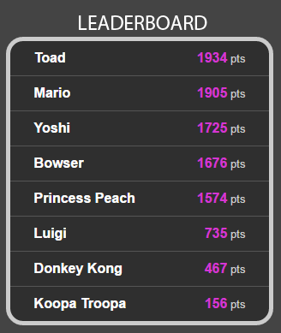

Figure 5 - Leader Board

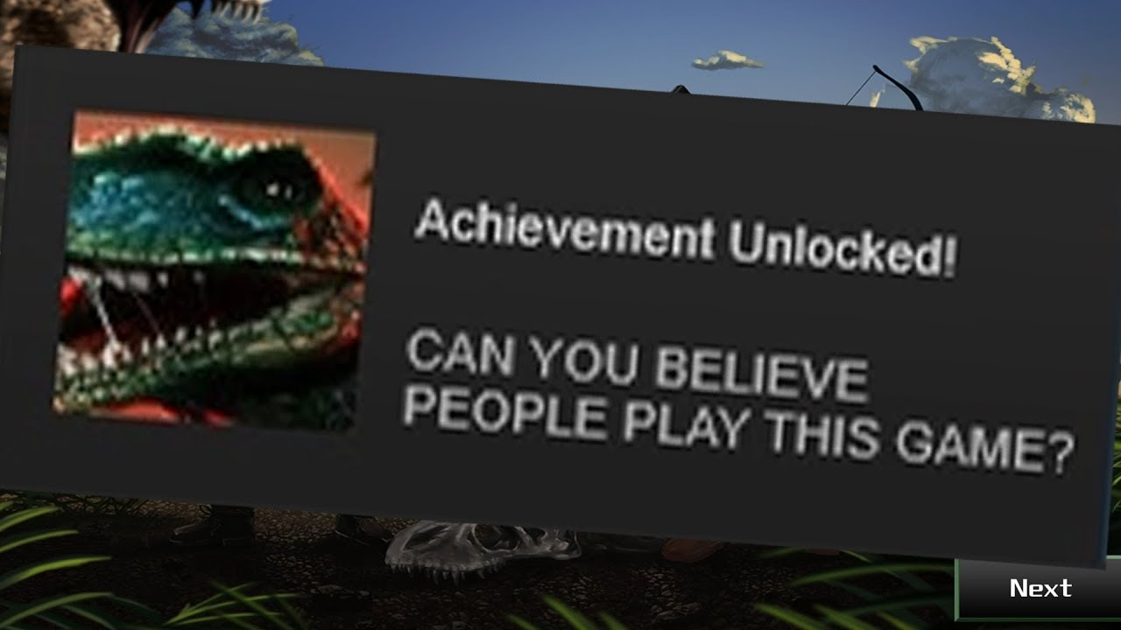

Figure 6 - Achievements

|  |  |  |  |
| --- | --- | --- | --- |
| Engagement Method | Explanation & Strategy | Who’s in charge | Feedback |
| Activity Testing | During the development of the game we can send off some of the activity sheets to schools in the Bournemouth/Poole Conurbation along with “prizes” normally consisting of chocolate eggs/sweets. This will hopefully give us an idea of whether or not the kids enjoyed the activities, and whether the teachers found it easy to teach using. | Managing Director (Marketing) | This Would hopefully generate some feedback from the kids and the teachers. |
| Fact Collecting | We could host a competition for kids on our website to find the most interesting & obscure dinosaur fact. We can then vote on the coolest and the winner gets £50. We can share this information to the teachers of the kids to get them involved in spreading the competition. This will allow us to collect a decent amount of cool facts, it also lets us get an idea of what kind of facts kids find cool about dinosaurs. If they like knowing the size and scale, or if they like knowing the living conditions. | Managing Director (Marketing) | We can gather some information from the parents about how much they know about dinosaurs and how much their kids knows or how much their kid enjoys dinosaurs. |
| Application Testing | Finally, we the game is in the final stages of testing we can send somebody to go along to a few schools challenging a class or two who can get the highest scores, as incentive we can bring a bunch of sandwiches, fruit & snacks along for the kids. Each winner gets a chocolate dinosaur as a prize. This will allow the managing director to get a first-hand experience of how well the application goes down with children. This can help us decide if any last-minute changes need to be made to the app. | Managing Director (Marketing) | The Managing Director can collect information about how the kids handle the game, if it’s too difficult and needs to be modified or if they pick it up nicely, he can also see if they are enjoying it. |

## 1. 3 – Engage Target Audience:



Figure 7 - Activity Sheets



Figure 8 - Kids Testing

# Section 2 – Product Development Plan:

## 2.1 – Resources Needed:

Internal Staff:

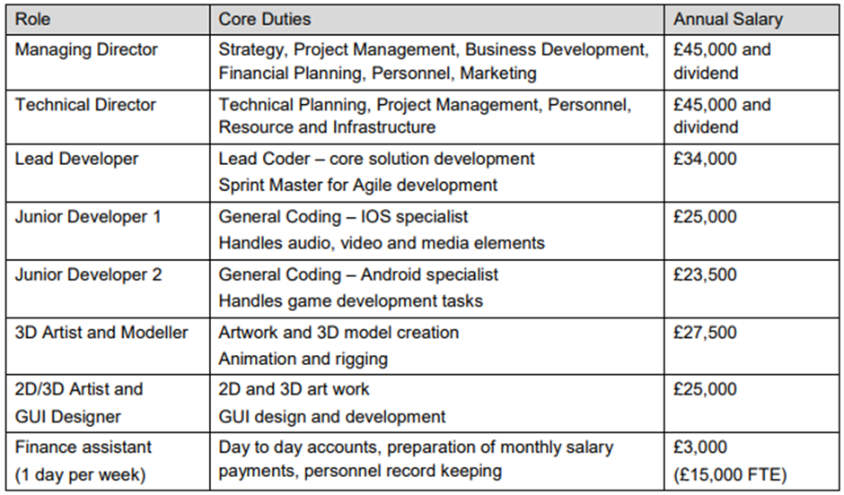

Figure - Internal Staff

Some of the key information on this table helped guide my hand when it came to deciding who worked on what, for example when it came to porting my application over to IOS, I made sure to use the Junior developer 1 as much as possible, hopefully this would allow work to flow much smoother, then if I had the junior developer 2 work on it. This also meant that I was able to cut a little time back off of situations like that.

|  |  |  |  |  |  |
| --- | --- | --- | --- | --- | --- |
| Freelancer | Core Duties | Skills | Explanation | Experience | Payment |
| Videography Freelancer | Record & Edit Videos | Video Producer, Video Editor,  Audio Editor,  Camera Operator | Tom is an English based Video producer who highly rated and very skilled. | Director of Human Element. Years in the industry | £35/hr |
| Sound Designer | Design Audio For Game/App | Music Composer,  Sound Designer,  Sound Mixer/Engineer | Conor is again English based, he has is also highly rated. | Worked on, FIFA, Odeon, Roche & Nivea | £35/hr |
| 3D Modeller | Contingency, Help Finish 3D Models | 3D Sculptor & Modeller | Martin English based, 5-star rating. | 15 of industry experience. | £25/hr |

Freelancers:

## 2.2 – Product Development Plan:

### 2.2.1 – Project Structure:

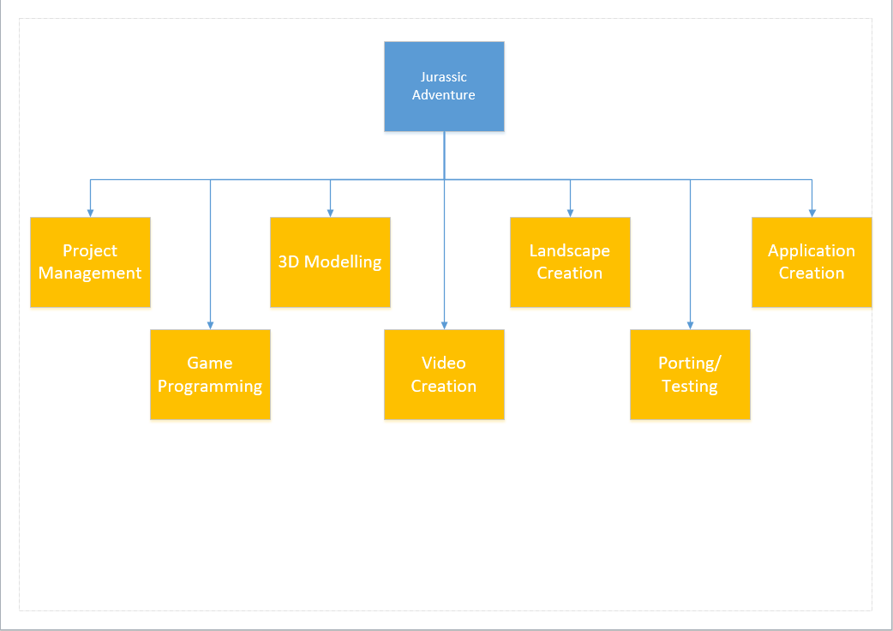

Figure - Top Level Themes

When it came to splitting this project into top level themes, I decided that it would be best to split them into the key features that the museum asked for, this allowed us to make sure these are a priority that that they are worked on enough. On top of this I thought it would be best to have project management theme as well, as it allows you to define the pre-start work that needs to be done. I also added porting & testing at the end so that we allow ourselves enough time to bug test & fix the product before delivering it March 27th.

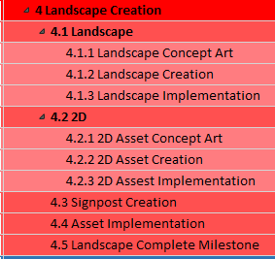

Figure - Task Breakdown

### 2.2.2 – Tasks and Sub-Task Definition:

As you can see in Fig. 11, I have structed the tasks so that they can flow easily from on to another, trying to keep similar work close together and grouping that work into tasks and sub-tasks. In this example you can see that I have all of the Landscape development subtasks grouped together under the landscape task.

### 2.2.3 – Task Duration & Resource Allocation:

When it came to task duration there where parts of it that I was more comfortable with than others, for example the application development, game programming, porting and testing are all parts that I think I have a good understanding of how long they should take to be done to a professional level. However, when it came to parts such as the video film & edit, I had to go and do some research as to how long it would take individuals to set-up film, direct then edit. I decided to follow the advice I got from (Reddit, 2019). As it gave me a run down on the filming duration/video length ratio. Then when it came to the asset creation & modelling, I decided to ask some of the technical students on the course for their input, they gave me a basic understanding of how long certain tasks take compared to others, on top of this information I was given, I choose to give certain tasks I wasn’t too sure about an extra day or two, just to make sure I wasn’t over working my employees.

### 2.2.4 – Building the Project Schedule:

When it came to building the schedule, I used auto scheduler for most of my tasks, I only manually scheduled 4 tasks. This was because I wanted to have a split in between putting ads out for freelancers and having the interviews with them, instead of my technical manager spending 2 days straight trying to organise immediate interviews. I never had too many over allocations in my project, I think this is mainly to do with the fact that I started by putting the predecessors in, for a lot of tasks this was easy because you would know that you need to finish making the 3D models before you can implement them into the application. However, there were a few times that I missed predecessors or just didn’t expect tasks to over lap which left me with over-allocation. To deal with this, I went back to the Gantt chart and looked to see if either of the tasks had more free time ahead of them until they were needed or if they were being waited on somewhere else already. If either of these were the case, I would make busy task the predecessor for the other, I was hoping this would make my project more time efficient.

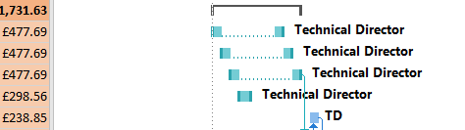

Figure - Manual Scheduling

I used recurring tasks for the weekly update meeting, weekly financial meeting and the monthly museum update. To implement these, I clicked the drop-down box on insert task, selected recurring task, then worked on the necessary start and end dates. Using them added around 117 tasks, so I’m thankful I didn’t have to make those manually.

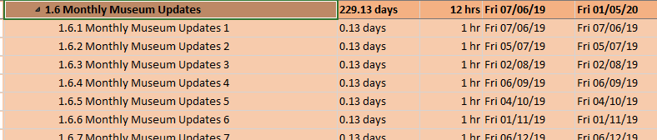

Figure - Recurring Tasks

When I first finished adding duration & allocation all of the staff to the project (and fixing any over allocations), I had the project finish a few days after the deadline, to fix this I went back over the project to see when certain staff aren’t working and seeing if they could possible help other staff on longer and more drawn out tasks, or even if they could help cut down the bottle neck tasks.

### 2.2.5 – Setting Milestones:

Making the milestones for the project wasn’t too much of a stretch, at first only had it so that there was a milestone at the end of every top level theme, however when it came to looking through the finance side of the documentation, I saw that my milestones didn’t help balancing out the payment plan very well, so I went back in and added two more milestones, around the middle of the two big bottle necks of the application, these were in the 3D models and the game programming, this was so that I could split the payments more evenly over the development so that the museum would be more happy with it.

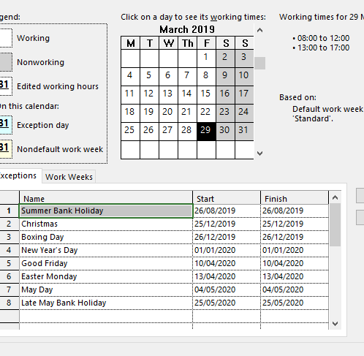

Figure - Project Calendar

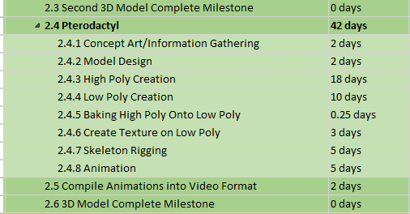

Figure - 3D Model Milestones

### 2.2.6 – Global Project Parameters within MS Project 2016:

I followed the video given to use before tampered with the software at all, this allowed me to have the project set up with appropriate start/end dates, the correct working week, auto scheduled tasks and the holiday filled calendar. When adding the dates to the calendar to made sure to only add holidays that happened within the project date.

### 2.2.7 – Gantt Chart Appearance:

The Visual appearance of the Gantt chart view was changed to outline which tasks where TLT’s and which were sub-tasks, the lighter the coloured background, the further down the task was. I am aware that you can change the colours of the lines on the Gantt chart itself to identify which resource is working on which section by assign resources with flags, however I personally didn’t like the way this looked so I opted to steer clear of it.

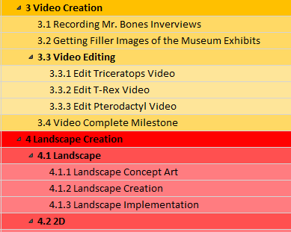

Figure - Gantt Chart Appearance

# Section 3 – Financial & Commercial Data:

## 3.1 – Estimated Costs:

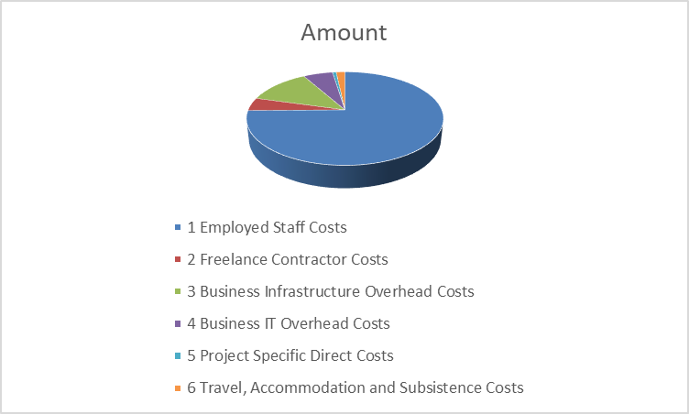

Figure - Graph of Expenditure

### 3.1.1 – Total Cost:

As you can see in Fig. 18 the total cost of the project including VAT comes to £142,478.29.

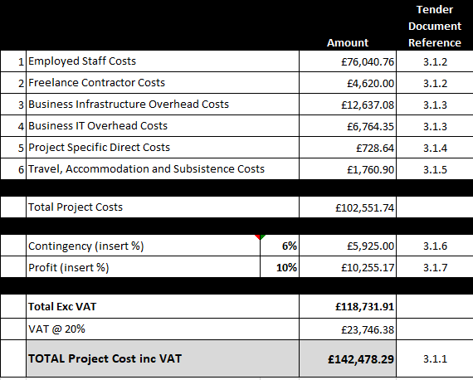

Figure - Cost Summary

### 3.1.2 – Staffing Cost:

As you can see in Fig. 18 half of the total cost comes from staffing costs. When it came to employed staff, I got there annual salary and added national insurance onto it, I then proceeded to work out their individual cost per hours, I did this by dividing there NI Annual Salary by 46.4 the average number of weeks worked a year, then dividing this number by 40 the number of hours in a working week. Once I had their cost an hour, I multiplied it by the amount of hours they worked, I got this data from project.

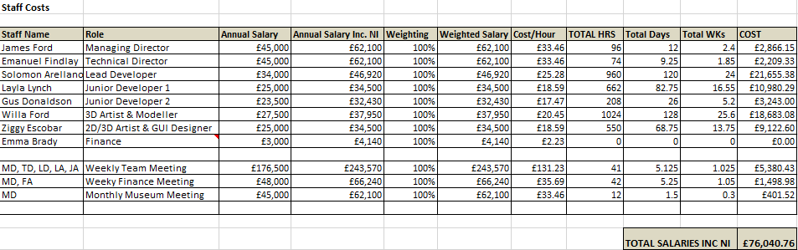

Figure - Staff Salary

As for the freelance employees, they were much easier as they advertised their hourly rates, this allowed me to just get the amount of hours they worked in the MS project document and multiple it by the hourly rate. As you can see Martin M. – 3D modeller, has no hours worked, this is because he is a Contingency Freelancer, I have him in place in case throughout the project Willa Ford falls behind, goes on extended holiday or leaves the company, then I have a freelancer I can try to secure, and at the very least I can use his hourly rate as a base of what that kind of contingency would need.

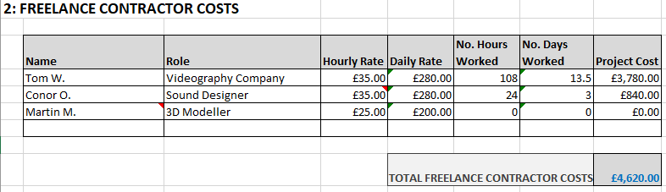

Figure - Freelancer Cost

3.1.3 – Operational Overhead Cost:

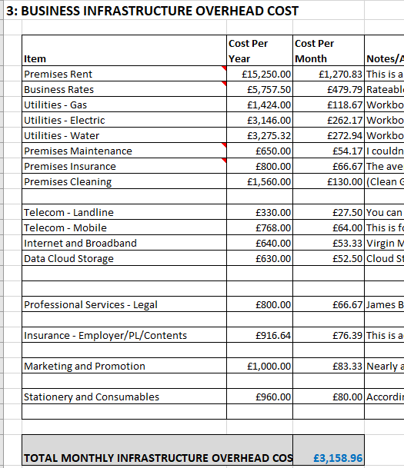

Figure - Infrastructure Overhead Costs

The Overhead costs took the longest amount of time for me to set-up in the document, there was a lot of research that had to be done to be able to get reasonable information to base my own figures on. For example, the rent is a real property in Bournemouth (Zoopla, 2019), I got quote from Virgin Media for have Virgin Landline, Mobile and Broad band (Virginmediabusiness.co.uk, 2019). On top of this I also got a quote from (Money Super Market, 2019) for the Public Liability as you can see in Fig. 14.

There are a few notes in the excel sheet as you can see, this were I was noting out what was going to have Contingency fees, how much there were going to be and so on. There is also a large amount of information on this page explaining how I came about each figure, for example, working out the Business rates, and finding out that the property that is rented is, according to the (GOV.UK, 2019) £11,750 rateable which when you multiply that by the business multiplier which is currently £0.49.3 you get the business rate per year.

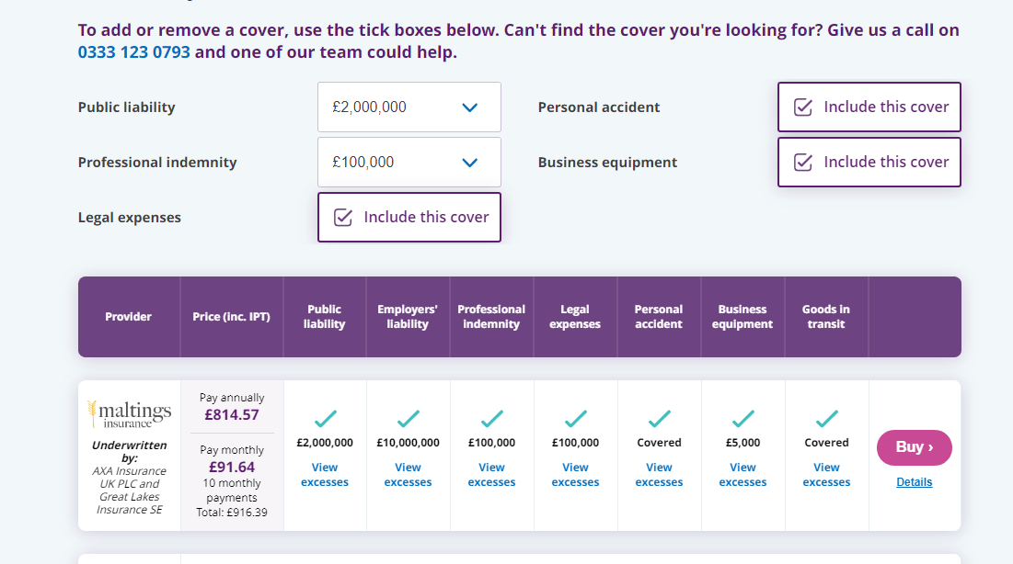

Figure - Money Super Market Quote (PL)

As for the IT Overhead costs, I’ve gone through and looked at all the software’s that should be needed for this project like, Z-Brush, Substance Painter, Maya, Visual Studio, Office & Unity. I think needed to split those up into who needed what, obviously the programmers wouldn’t need to use substance painter at any point. I also looked at buying pre-built computers, this means that all of the computers come with windows 10 installed on them.

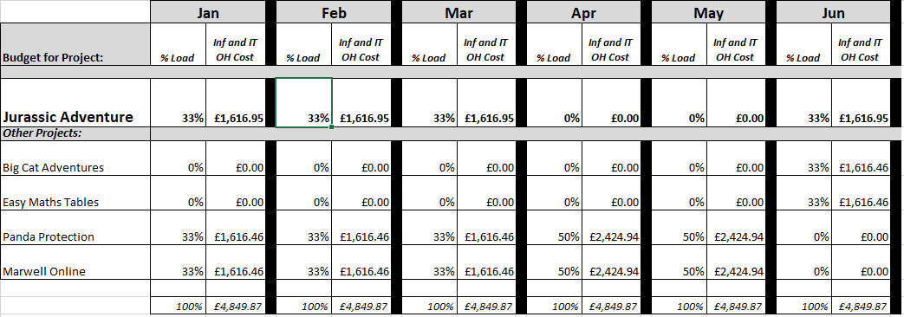

Figure - 2020 Total Overhead Costs

Then finally for the total OH cost section, I split the Load evenly between the projects that were active at the time.

### 3.1.4 – Specific Resources & Equipment:

The onetime costs I could come up with for this project where things like the prize’s & competition we set up with the schools in the area to get the kids to give us user feedback. The catering will be for the full application testing, it will be to help convince the schools to let us come down and have the kids play with application. The price was from the companies quotes on their website (Crumbs, 2019).

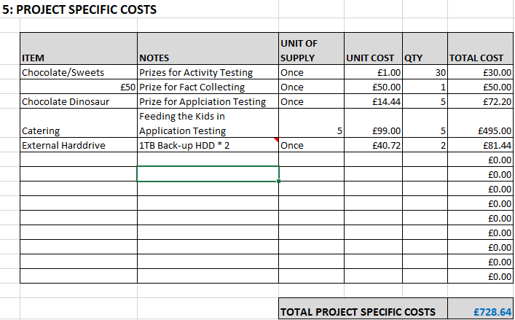

Figure - Specific Costs

The External Hard Drives where found at (Amazon, 2019), they are large EHD’s and should be perfect for the lead programmer and 3D modeller to constantly backup their work to.

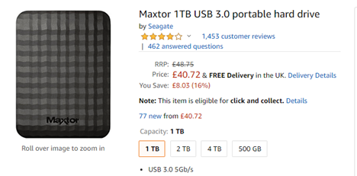

Figure - Portable Hard Drive

### 3.1.5 – Project Management Cost:

The travel cost was based on train fares. The only travel costs I felt necessary for this kind of project was for the managing director to attend the monthly up date meetings with the museum and for the videography freelancer to get down to London to film in the museum, his train tickets were more expensive because he comes from Manchester. Accommodation also had to be provided for the videography freelancer whilst he was in London.

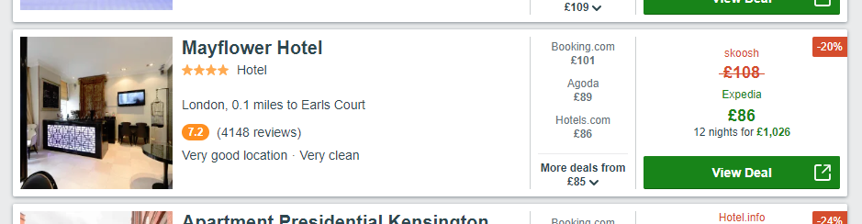

Figure - Hotel Prices

### 3.1.6 – Contingency Costs:

For the contingency costs, I went back through all of the other costs and all of the parts I wasn’t totally comfortable with and gave myself a small amount of wriggle room, to fix any unforeseen issues that might arise.

There are my Contingency Costs:-

* £5,000 Freelance 3D modeller - about 200 hours of work
* £300 Business Rates may Fluctuate in 2020-2021
* £325 Premises maintenance
* £200 Premises Insurance
* £100 Trains may get more expensive if they get closer to holiday periods

This gave me a 6% contingency of my total project cost, the £5,000 for a freelancer is about 5 weeks of full-time employment to make sure that we can produce the application on time.

### 3.1.7 – Profit Margin:

|  |  |  |  |
| --- | --- | --- | --- |
| Date | Milestone | Payment | Amount |
| 14/06/19 | Project Start | 5% | £7,123.91 |
| 28/08/19 | IHL Complete | 10% | £14,247.83 |
| 26/08/19 | Core Game Completed | 15% | £21,371.74 |
| 11/10/19 | Second 3D Model Complete Milestone | 25% | £35,619.57 |
| 19/12/19 | Video Complete | 15% | £21,371.74 |
| 04/02/20 | Application Complete | 20% | £28,495.66 |
| 27/02/20 | Porting/Testing | 20% | £28,495.66 |

As for the profit margin, I found it really difficult to find any examples of times that companies have released their profit margins, this left me at odd situation where I kind of just had to guess, so I decided to see how well other Dino based applications were doing on the app stores, I saw that Dinosaur games actually did really well in the kids section of apps, I found a number of them in the top 50 tops, (Appbite.com. (2019)), (iPhone App Store. (2019)), (App Store. (2019)). These are just three of the better ones, but because of this I decided that I was going to ask for a profit margin of 10% and because of this I would also have to have a good warranty.

## 3.2 – Payment Plan:

This payment plan is set up in a way that splits the payment of the product pretty evenly across the whole development cycle, it is a little bottom heavy, however that’s just the nature of how my milestones turned out.

## 3.3 – Copyright & Intellectual Property Rights:

As you can see from Fig. 21, were have allocated resources to having a legal representative, I plan to use them to help with the creation of the contracts with the freelancers, this is to guarantee that we will own the rights to the media they create with us and also to make sure the contracts are solid with no possible loop holes. As for giving the rights over to the museum, as soon as the last payment has been delivered to the company then I would be more than happy to sign over all of the IP to the museum for their new application, again this would be with the help of the legal representative.

## 3.4 – Support & Updates:

For the 12 months are the launch there will be a “warranty” in place for the app, whereas eSolutions would be happy to come back and fix any large bugs/errors in the product, these would include cases such as, the UI/App is unusable on one of the agreed upon devices, the game is unplayable/broken. Any of the key features are far from what was agreed upon, or if the museum declares that the product is far too different to the product they specified. In these cases, we could take the product back and fix it any way we can.

On the flip side to this however, in the applications design we have spent some time making sure that the UI in particular is ready for a larger amount of assets added to it, so if the museum would like to get in contact with us and hire us again the implement more content to the application, then it would be much easier to do now. This could help the application spread better as well because people will see it getting some kind of updates.

# Appendix:

## Work Breakdown Structure:

Top Level Themes:

1. Project Management
2. 3D Modelling
3. Video Creation
4. Landscape Creation
5. Application Creation
6. Game Programming
7. Porting/Testing

Jurassic Adventure:-

1. Project Management:-
   1. Hiring Contractors Needed
      1. Hire 3D Modeller
      2. Hire Videography Company
      3. Hire Sound Designer
      4. Look into prices for contingency freelancers
   2. Briefing Contractors on Requirements
   3. Briefing Staff on Project Assignments.
   4. Project Assignment Start Milestone
   5. Weekly Meetings
   6. Monthly Museum Updates
   7. Finance Update – Weekly
2. 3D Modelling:-
   1. Triceratops:-
      1. Concept Art/Information Gathering
      2. Model Design
      3. High Poly Creation
      4. Low Poly Creation
      5. Baking high poly onto low poly
      6. Create Texture on low poly
      7. Skeleton Rigging
      8. Animation
   2. T-Rex:-
      1. Concept Art/Information Gathering
      2. Model Design
      3. High Poly Creation
      4. Low Poly Creation
      5. Baking high poly onto low poly
      6. Create Texture on low poly
      7. Skeleton Rigging
      8. Animation
   3. Second 3D Model Complete Milestone
   4. Pterodactyl:-
      1. Concept Art/Information Gathering
      2. Model Design
      3. High Poly Creation
      4. Low Poly Creation
      5. Baking high poly onto low poly
      6. Create Texture on low poly
      7. Skeleton Rigging
      8. Animation
   5. Compile Animations into video format
   6. 3D Model Complete Milestone
3. Video Creation:-
   1. Recording Mr. Bones Interviews
   2. Getting Filler images of the Museum Exhibits
   3. Video Editing
      1. Edit Triceratops Video
      2. Edit T-Rex Video
      3. Edit Pterodactyl Video
   4. Video Complete Milestone
4. Landscape Creation:-
   1. Landscape
      1. Landscape Concept Art
      2. Landscape Creation
      3. Landscape Implementation
   2. 2D
      1. 2D Asset Concept Art
      2. 2D Asset Creation
      3. 2D Asset Implementation
   3. Signpost Creation – Wait For Quiz Creation
   4. Asset Implementation
   5. Landscape Complete Milestone
5. Application Creation:-
   1. Basic Application Designs
   2. Menu Interface
   3. Implementation
      1. Concept Art Implementation
      2. 3D Model Implementation
      3. Video Implementation
      4. Activity Implementation
      5. Game Implementation
   4. Complete Application Design Finalisation
   5. Application Complete Milestone
6. Game Programming:-
   1. Basic Level Creation
   2. 2D Asset Creation
   3. Player Movement
   4. Learning Activities Creation
      1. Crossword Creation
      2. Word-Searches
      3. Fact-Sheets
      4. Colour Sheets
      5. Quiz Creation
   5. Level Device Implementation (Keys & Gates, Level Progression)
   6. Side Scroller Core (Jumping/Physics)
   7. Scoring System
   8. Core Game Complete Milestone
   9. Sound Creation
   10. Implementation
       1. Landscape Implementation
       2. Video Implementation
       3. Puzzle Implementation
       4. 3D Model Implementation
       5. Sound Implementation
   11. Additional Features
       1. Leader Board Design/Functionality
       2. Leader Board Implementation
       3. Friend System
       4. Achievement Implementation
   12. Game Complete Milestone
7. Porting/Testing:-
   1. Porting
      1. Port to Higher Versions of Android
      2. Port to IOS 12
      3. Port to Higher IOS Versions
      4. Update Resolution Options
      5. Update Formatting Options
      6. Port to Android Tablets
      7. Port to IOS Tablets
      8. Auto Detect Hardware Resolution & Resize Appropriately
   2. Porting Complete Milestone
   3. Testing
      1. Spell Checking
      2. Menu System
         1. Button Testing
         2. Link Testing
         3. Touch Screen Testing
         4. Gesture Testing
      3. Engaging Audience
         1. Activity Testing
         2. Fact Collecting
         3. Application Testing
      4. Image Loading
      5. Video Loading
      6. Audio Testing
      7. Activity Sheet
         1. Viewing
         2. Offline Downloading
         3. Printing
      8. Performance Testing
      9. Stress Testing
      10. Compatibility Testing
          1. Android Testing
          2. IOS Testing
          3. Tablet Testing
      11. Interfacing Testing
   4. Porting/Testing Complete Milestone

## References:

### Figures:

Figure 3:

Wikipedia (2019). *Triceratops*. [image] Available at: https://en.wikipedia.org/wiki/Triceratops#/media/File:Triceratops_by_Tom_Patker.png [Accessed 29 Mar. 2019].

Wikipedia (2019). *Tyrannosaurus*. [image] Available at: https://en.wikipedia.org/wiki/Tyrannosaurus#/media/File:Tyrannosaurus-rex-Profile-steveoc86.png [Accessed 29 Mar. 2019].

Wikipedia (2019). *Pterodactylus*. [image] Available at: https://en.wikipedia.org/wiki/Pterodactylus#/media/File:Pterodactylus_BMMS7_life.png [Accessed 29 Mar. 2019].

Figure 5:

101 Computing (2019). *Leaderboard using Python*. [image] Available at: https://www.101computing.net/leaderboard/ [Accessed 29 Mar. 2019].

Figure 6:

YouTube (2019). *Developers: Don't Play Our Game (Dinosaur Hunt)*. [image] Available at: https://www.youtube.com/watch?v=LCVFfzueiF8 [Accessed 29 Mar. 2019].

Figure 7:

Digital Trends (2019). *20 Android and iOS apps for kids to keep them entertained (and quiet)*. [image] Available at: https://www.digitaltrends.com/mobile/best-apps-for-kids/ [Accessed 29 Mar. 2019].

Figure 8:

Sesame-en.tokyo (2019). *Kids Land Club – Afternoon Program (2:00 pm~ 5:00 pm) | Welcome to Sesame International Preschool !*. [image] Available at: http://sesame-en.tokyo/?page_id=540 [Accessed 29 Mar. 2019].

Figure 14:

Money Super Market. (2019). *Business Insurance*. [online] Available at: https://moneysupermarket.quote.simplybusiness.co.uk/q/business/new_business/quote_comparison/5c9da4ca246cb4003435b56c [Accessed 29 Mar. 2019].

Figure 17:

Amazon.co.uk. (2019). *1TB Portable Hard Drive*. [online] Available at: https://www.amazon.co.uk/Maxtor-1TB-portable-hard-drive/dp/B01AJWNYLA/ref=sr_1_6?crid=PQKAEIBMB18Q&keywords=external+hard+drives+1tb&qid=1553838729&s=gateway&sprefix=External+H%2Caps%2C134&sr=8-6 [Accessed 29 Mar. 2019].

Figure 18:

Trivago.co.uk. (2019). *Are you a human or a robot?*. [online] Available at: https://www.trivago.co.uk/?aDateRange%5Barr%5D=2019-11-27&aDateRange%5Bdep%5D=2019-12-09&aPriceRange%5Bfrom%5D=0&aPriceRange%5Bto%5D=0&iRoomType=1&aRooms%5B0%5D%5Badults%5D=1&cpt2=1974871%2F500&iViewType=0&bIsSeoPage=0&sortingId=1&slideoutsPageItemId=&iGeoDistanceLimit=16093&address=&addressGeoCode=&offset=0 [Accessed 29 Mar. 2019].

### Freelancers:

M, M. (2019). *Hire Martin M. on PeoplePerHour*. [online] PeoplePerHour.com. Available at: https://www.peopleperhour.com/freelancer/martin/3d-sculptor-and-modeller/165085 [Accessed 29 Mar. 2019].

O, C. (2019). *Hire Conor O. on PeoplePerHour*. [online] PeoplePerHour.com. Available at: https://www.peopleperhour.com/freelancer/conor/music-composer-sound-designer-sou/25529 [Accessed 29 Mar. 2019].

W, T. (2019). *Hire Tom W. on PeoplePerHour*. [online] PeoplePerHour.com. Available at: https://www.peopleperhour.com/freelancer/tom/video-producer-video-editor-audio/1239007 [Accessed 29 Mar. 2019].

### Websites:

Worksheets. (2019). Crossword Puzzle Maker | World Famous from the Teacher's Corner. [online] Available at: https://worksheets.theteacherscorner.net/make-your-own/crossword/ [Accessed 29 Mar. 2019].

Puzzlemaker. (2019). Make your own Word Search with Discovery Education's Puzzlemaker!. [online] Available at: http://puzzlemaker.discoveryeducation.com/WordSearchSetupForm.asp [Accessed 29 Mar. 2019].

Appbite.com. (2019). *Dinorama*. [online] Available at: http://www.appbite.com/dinorama-iphone-game-review/ [Accessed 29 Mar. 2019].

IPhone App Store. (2019). *Dinosaurs 360*. [online] Available at: https://itunes.apple.com/gb/app/dinosaurs-360/id350115724?mt=8 [Accessed 29 Mar. 2019].

App Store. (2019). *‎Archaeologist: Dinosaurs Games*. [online] Available at: https://itunes.apple.com/gb/app/archaeologist-dinosaurs-games/id669920885?mt=8 [Accessed 29 Mar. 2019].

Reddit.com. (2019). *Video Editors: How long does it take you to edit? : Filmmakers*. [online] Available at: https://www.reddit.com/r/Filmmakers/comments/5iqzbr/video_editors_how_long_does_it_take_you_to_edit/ We could not find: [Accessed 29 Mar. 2019].

Businesselectricityprices.org.uk. (2019). *Water Deregulation Pricing Guide for Businesses*. [online] Available at: https://www.businesselectricityprices.org.uk/water-prices/ [Accessed 29 Mar. 2019].

Smarter Business. (2019). *What is the Average Business Energy Consumption in the UK?*. [online] Available at: https://smarterbusiness.co.uk/what-is-the-average-business-energy-consumption-in-the-uk/ [Accessed 29 Mar. 2019].

Taxinsider.co.uk. (2019). *Tax Relief for Business Expenses --- Premises Maintenance and Repairs*. [online] Available at: https://www.taxinsider.co.uk/930-Tax_Relief_for_Business_Expenses_Premises_Maintenance_and_Repairs.html [Accessed 29 Mar. 2019].

Bought By Many. (2019). *How much does public liability insurance cost?*. [online] Available at: https://boughtbymany.com/news/article/how-much-does-public-liability-insurance-cost/ [Accessed 29 Mar. 2019].

Clean-genie-bournemouth.co.uk. (2019). *Office Cleaning Bournemouth | Clean Genie Bournemouth*. [online] Available at: http://www.clean-genie-bournemouth.co.uk/office-cleaning.php [Accessed 29 Mar. 2019].

Virginmediabusiness.co.uk. (2019). *Business Phone Lines | Virgin Media Business*. [online] Available at: https://www.virginmediabusiness.co.uk/connectivity/phone-lines-systems/business-phonelines/ [Accessed 29 Mar. 2019].

Virginmediabusiness.co.uk. (2019). *Samsung Galaxy S10 Plus | Virgin Media Business*. [online] Available at: https://www.virginmediabusiness.co.uk/connectivity/business-mobile/samsung-galaxy-s10-plus/ [Accessed 29 Mar. 2019].

Virginmediabusiness.co.uk. (2019). *Business Broadband Packages | Virgin Media Business*. [online] Available at: https://www.virginmediabusiness.co.uk/connectivity/internet-access/business-broadband/ [Accessed 29 Mar. 2019].

Products.office.com. (2019). *OneDrive for Business – Plans & Pricing | Office 365*. [online] Available at: https://products.office.com/en-GB/onedrive-for-business/compare-onedrive-for-business-plans [Accessed 29 Mar. 2019].

Vouchedfor.co.uk. (2019). *Find Top-Rated Financial Advisers, Mortgage Advisers, Solicitors and Accountants*. [online] Available at: https://www.vouchedfor.co.uk/solicitor/poole/22632-james-braund [Accessed 29 Mar. 2019].

Vouchedfor.co.uk. (2019). *How much does a solicitor charge?*. [online] Available at: https://www.vouchedfor.co.uk/blog/How-much-does-solicitor-charge%3F [Accessed 29 Mar. 2019].

Average Office Supply Costs Per Employee. (2019). 1st ed. [ebook] Los Angeles: LAC-Group, p.1. Available at: https://legalsupportnetwork.co.uk/sites/default/files/LAC%20Group%20-%20Average%20Office%20Supply%20Costs%20Per%20Employee%20(edit)[1]%20copy.pdf [Accessed 29 Mar. 2019].

Crumbs. (2019). *Food Services and Event Catering in Bournemouth & Poole | The Crumbs Project in Dorset*. [online] Available at: https://www.crumbs.org.uk/food-services/ [Accessed 29 Mar. 2019].

GOV.UK. (2019). *Estimate your business rates*. [online] Available at: https://www.gov.uk/calculate-your-business-rates [Accessed 29 Mar. 2019].

Tax.service.gov.uk. (2019). *Summary valuation*. [online] Available at: https://www.tax.service.gov.uk/business-rates-find/summary/17958807000?uarn=6778540000 [Accessed 29 Mar. 2019].

Gazprom-energy.co.uk. (2019). *How are business rates calculated?*. [online] Available at: https://www.gazprom-energy.co.uk/help-and-support/bills-payments/how-are-business-rates-calculated/ [Accessed 29 Mar. 2019].

Zoopla (2019). *Photos of Unit 10 New Fields Business Park, Poole BH17 - 49426033 - Zoopla*. [image] Available at: https://www.zoopla.co.uk/to-rent/commercial/details/photos/49426033?search_identifier=cb50a4f9af81d9ec7265fe8d55362446 [Accessed 29 Mar. 2019].

Amazon.co.uk. (2019). *Chocolate Dinosaur ButtonChocs*. [online] Available at: https://www.amazon.co.uk/Dinosaur-Rooarrr-Chocolate-Dinosaur-ButtonChocs/dp/B00N9XCKOO/ref=asc_df_B00N9XCKOO/?tag=googshopuk-21&linkCode=df0&hvadid=310685469787&hvpos=1o9&hvnetw=g&hvrand=10541998707674208162&hvpone=&hvptwo=&hvqmt=&hvdev=c&hvdvcmdl=&hvlocint=&hvlocphy=9045712&hvtargid=pla-564020553765&psc=1 [Accessed 29 Mar. 2019].

Thetrainline.com. (2019). *Comparing Train Prices*. [online] Available at: https://www.thetrainline.com/book/results?origin=d8cf21ba0035a9e702ec5390de86ba76&destination=2144c4ddc11461cf9b03af198933e8df&outwardDate=2019-05-06T11%3A00%3A00&outwardDateType=departAfter&journeySearchType=return&passengers%5B%5D=1989-03-29&inwardDate=2019-05-06T14%3A15%3A00&inwardDateType=departAfter&selectedOutward=UvvRzgeCoiA%3D%3AiVeaUSOdPMs%3D&selectedInward=QU6FDi7wzt4%3D%3AmXbR9%2F%2BYuAo%3D [Accessed 29 Mar. 2019].

Pcworld.co.uk. (2019). *Desktop PCs - Best Desktop PCs Offers | PC World*. [online] Available at: https://www.pcworld.co.uk/gbuk/computing/desktop-pcs/desktop-pcs/1093_8225_71255_xx_ba00010707-bv00308577%7Cbv00308581%7Cbv00308585/xx-criteria.html [Accessed 29 Mar. 2019].

Amazon.co.uk. (2019). *21.5" Monitor*. [online] Available at: https://www.amazon.co.uk/AOC-21-5-Monitor-E2270SWDN-Black/dp/B016UPDUBO/ref=sr_1_2?fst=as%3Aoff&qid=1553843310&refinements=p_n_feature_browse-bin%3A319911031&rnid=319909031&s=computers&sr=1-2 [Accessed 29 Mar. 2019].

Products.office.com. (2019). *Compare Project Management Software | Microsoft Project*. [online] Available at: https://products.office.com/en-GB/project/compare-microsoft-project-management-software?tab=1&OCID=AID737190_SEM_goVz1SrM&MarinID=sgoVz1SrM|250608197489|%2Bms%20%2Bproject|b|c||48551593141|aud-312771920789:kwd-18709234952&lnkd=Google_O365SMB_App&gclid=Cj0KCQjwhPfkBRD0ARIsAAcYycHEPez6xI5j1a0MG9qHVa1hAAICieXqZSffCbK8Vl9JjiSaqK_RrEUaAoMlEALw_wcB [Accessed 29 Mar. 2019].

Products.office.com. (2019). *Compare All Microsoft Office Products | Microsoft Office*. [online] Available at: https://products.office.com/en-GB/compare-all-microsoft-office-products-b?tab=2&OCID=AID737190_SEM_nhI5WIgC&MarinID=snhI5WIgC|340691303440|microsoft%20office|e|c||55258418287|aud-312771920869:kwd-11647891&lnkd=Google_O365SMB_NI&gclid=Cj0KCQjwhPfkBRD0ARIsAAcYycFUwvyfcmthCblu2ngaVVBl1aqUI_kLXApi_7xuFdop1bOX7lUbsj0aAinsEALw_wcB [Accessed 29 Mar. 2019].

Amazon.co.uk. (2019). *CyberPowerPC Warrior i7*. [online] Available at: https://www.amazon.co.uk/CyberpowerPC-Warrior-i7-1080-Gaming-PC/dp/B0716BJH6W/ref=asc_df_B0716BJH6W/?tag=googshopuk-21&linkCode=df0&hvadid=310841382891&hvpos=1o3&hvnetw=g&hvrand=17238303346279140349&hvpone=&hvptwo=&hvqmt=&hvdev=c&hvdvcmdl=&hvlocint=&hvlocphy=9045712&hvtargid=pla-576918338045&psc=1https://www.amazon.co.uk/Acer-K242HLbid-Monitor-Black-Panel/dp/B01L89GYRY/ref=sr_1_1?fst=as%3Aoff&qid=1553844551&refinements=p_n_feature_browse-bin%3A319914031&rnid=319909031&s=computers&sr=1-1 [Accessed 29 Mar. 2019].

Ibm.com. (2019). *Dedicated Cloud Servers and Hosting*. [online] Available at: https://www.ibm.com/cloud/info/dedicated-servers?S_PKG=AW&cm_mmc=Search_Google-_-Cloud_Cloud+Platform-_-WW_IUK-_-cloud+server_Exact_&cm_mmca1=000016GC&cm_mmca2=10006171&cm_mmca7=9045712&cm_mmca8=kwd-10605314275&cm_mmca9=_k_Cj0KCQjwhPfkBRD0ARIsAAcYycEKY7CnYgl3QmtxvsF_os7lrZBfjplYaCTOYlHl8LnzU90_vIuPhUIaAucvEALw_wcB_k_&cm_mmca10=293405015418&cm_mmca11=e&mkwid=_k_Cj0KCQjwhPfkBRD0ARIsAAcYycEKY7CnYgl3QmtxvsF_os7lrZBfjplYaCTOYlHl8LnzU90_vIuPhUIaAucvEALw_wcB_k_|1445|20469&cvosrc=ppc.google.cloud%20server&cvo_campaign=000016GC&cvo_crid=293405015418&Matchtype=e&gclid=Cj0KCQjwhPfkBRD0ARIsAAcYycEKY7CnYgl3QmtxvsF_os7lrZBfjplYaCTOYlHl8LnzU90_vIuPhUIaAucvEALw_wcB [Accessed 29 Mar. 2019].